Rent a Friend

There are a lot of people in this world, that are too shy or maybe just lack the communication skills to obtain company or new friends. Or maybe there is an upcoming event that they don't wish to go to alone for which they have an extra ticket. Perhaps your grandmother just wants to see you happy with a girlfriend/boyfriend. Overall there are a lot of occasions when you just wish that someone is there with you, be it an event, a family gathering or a company dinner.

In the course Systems III i want to develop a system that lets users submit the request for a friend/companion and on the other hand lets other users to apply as a companion.

Functional requirements
1. The system should allow the user to create and post ads for providing the friend service aswell as for posting ads for receiving the service. The system should enable the user to delete the post. The system also stores the information about the user, such as name, surname, telephone number and date of birth.

2. The system will seperate the posts depending on if the person is looking for a friend or is offering to be one in two seperate tabs. The posts on each tab will be ordered in a grid that will span vertically.

3. The system will include a chat window through which the users could privately communicate with each other to arrange meetings.

4. The system can only be used by registred and verified users for the protection of users themselves.

Non-functional requirements
1. The system must be able to process up to 100 posts per minute.

2. The system should be developed and deployed withing 2 months of system designs being finalized.

3. The data must be stored securely in multiple locations as to pervent data loss.

4. The system manages personal information, because of that the information must be encrypted and stored safely.

5. The system should allow the users to access the system from any location if it is connected to the internet.

6. The system should support 2 different types of users: Rentees and Friends.

7. The system must ensure 24/7 operation with an uptime of atleast 97%.

8. The system should be packaged as a web application. The installation should be enabled by running a install command.

9. The system should include all the necessary documentation for installation and maintenance.

Feasibility study

One of the possible solutions is the creation of a web app. This kind of solution satisfies all the functional and non-functional requirements.
The project does not face any legal consequences as everything that is needed for it's operation is completely legal in the EU. Only the user data must be stored securely and privately.
The proposed information system can be realized on open source software. The service will be free of charge for everyone. The systen does not impose any additional software or hardware cost. The project is also socially acceptable as it promotes making people feel more comfortable.

Matrix user role

Functions | Rentees | Friends
Create/Delete/Edit a Post looking for a friend | No | Yes
Create/Delete/Edit a Post offering to be a friend | Yes | No
Initiate a chat | Yes | Yes

Data dictionary
Entity | Description | Attribute | Type | Desc. of attr.
User | User of the system | id | int | Identified of the user
User | User of the system | name | varchar(255) | First name of the user
User | User of the system | last_name | varchar(255) | Last name of the user
User | User of the system | telephone | varchar(15) | Telephone number of the user
User | User of the system | date_of_birth | date | Date of birth of the user
Post | Post offering to be a friend or looking for one | title | varchar(255) | Title of the post
Post | Post offering to be a friend or looking for one | id | int | Identified of the post
Post | Post offering to be a friend or looking for one | type | varchar(255) | Type of the post
Post | Post offering to be a friend or looking for one | date | date | Date of creation
 |  |  |  | id of the creator
Post | Post offering to be a friend or looking for one | user_id | int | id of the creator
 |  |  |  | image of the creator
Post | Post offering to be a friend or looking for one | img | varchar(255) | image of the creator
 |  |  |  | hourly rate
Post | Post offering to be a friend or looking for one | rate | int | hourly rate
Rating | Rating of the user | id | int | Identified of the rating
Rating | Rating of the user | stars | int | Rating expressed in stars
Role | What kind of role the user has | id | int | Identified of the role
Role | What kind of role the user has | role | varchar(255) | What role belongs to the user

ER diagram
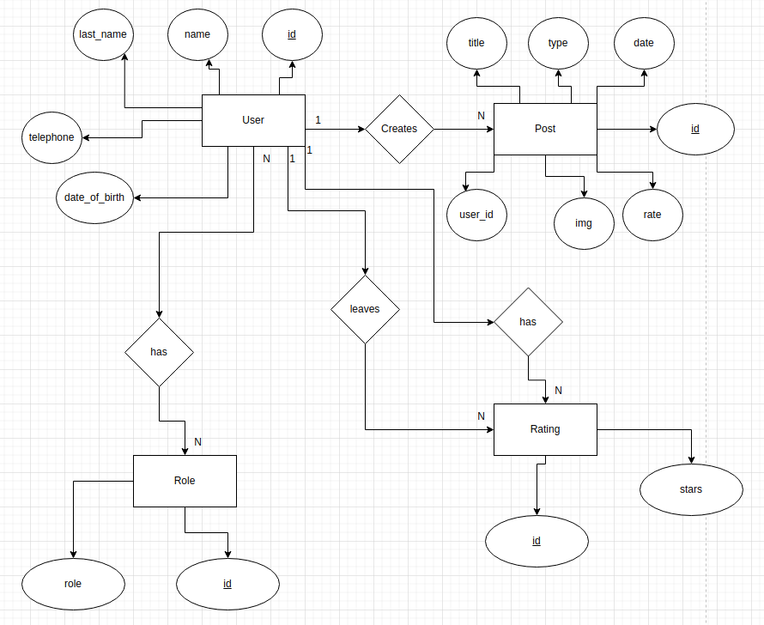

Relational diagram
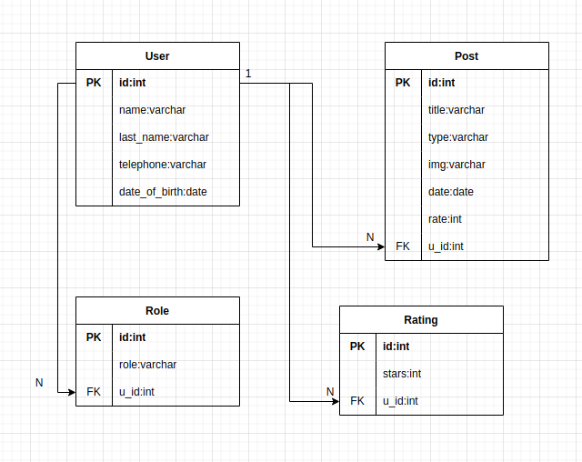

Functional decomposition diagram
